**Software Requirements Specification**

**for**

**KnowYourPlace**

**Version 4.0**

**Prepared by Kolli Nethre Sai (U101116FCS058)  
Midhilesh Majety (U101116FCS062)  
PV Preetham (U101116FCS093)  
Nikhil Kumar Guthi (U101116FCS078)**

**22nd September 2018**

**Table of Contents**

**Table of Contents ii**

**Revision History ii**

**1. Introduction 1**

1.1 Purpose 1

1.2 Document Conventions 1

1.3 Intended Audience and Reading Suggestions 1

1.4 Product Scope 1

1.5 References 1

**2. Overall Description 2**

2.1 Product Perspective 2

2.2 Product Functions 2

2.3 User Classes and Characteristics 2

2.4 Operating Environment 2

2.5 Design and Implementation Constraints 2

2.6 User Documentation 2

2.7 Assumptions and Dependencies 3

**3. External Interface Requirements 3**

3.1 User Interfaces 3

3.2 Hardware Interfaces 3

3.3 Software Interfaces 3

3.4 Communications Interfaces 3

**4. System Features 4**

4.1 System Feature 1 4

4.2 System Feature 2 (and so on) 4

**5. Other Nonfunctional Requirements 4**

5.1 Performance Requirements 4

5.2 Safety Requirements 5

5.3 Security Requirements 5

5.4 Software Quality Attributes 5

5.5 Business Rules 5

**6. Other Requirements 5**

**Appendix A: Glossary 5**

**Appendix B: Analysis Models 5**

**Appendix C: To Be Determined List 6**

**Revision History**

|  |  |  |  |
| --- | --- | --- | --- |
| **Name** | **Date** | **Reason For Changes** | **Version** |
| GROUP | 30th AUG 2018 | Initial version | 1.0 |
| GROUP | 7th SEPT 2018 | New Requirements have been added | 2.0 |
| GROUP | 14th SEPT 2018 | New Requirements have been added | 3.0 |
| GROUP | 23th SEPT 2018 | New Requirements have been added | 4.0 |

# Introduction

## Purpose

The purpose of this document is to present a detailed description about KnowYourPlace. It will explain the purpose and features of the system, what the website will do, the interfaces of the website*.*

## Document Conventions

In this document, headings are written in Times and body is written in Arial. Any comments inside <<>> are simply to help the reader to understand the point being made.

## Intended Audience and Reading Suggestions

*This document is intended for users, stakeholders and developers of the website.*

## Product Scope

*Our KnowYourPlace website provide information about the places in your city like tourist places and also provide the convenience of booking rooms, hostels, & homes. It also provide contact details of the hospitals, electricians, medical shops and malls.*

## References

*Srs_template-ieee.doc.*

# Overall Description

## Product Perspective

This is a self-contained product.

## Product Functions

Access all the information regarding a city or place.

Housing

booking of services

search of any required location in specific

search by location

links to jump to book certain services

## User Classes and Characteristics

As per the frequency of use, this product is highly beneficial to those who travel to new places or often get transferred or move to new places. However, this application has nothing, which is understandable only by travelers and could be simply used by anyone who’s not even very knowledgeable using applications as it is completely user friendly.

Housing specifications are very useful to those class of people who move to new places. In addition, the add ons we provide including tourist spots, events nearby etc. turn fruitful for the traveler class.

## Operating Environment

This is a web application so it is platform independent. All browsers support it. The current version is 1.0.

## Design and Implementation Constraints

This application has certain regulatory policies that give an upper hand to the company, which hired the developers over the developers. This does not have any hardware limitations as of the latest version. This application provides interface to certain other applications through booking links.

The languages used-

Database *- MYSQL*

backend connectivity *- PHP*

frontend and interface *- HTML,CSS,JAVASCRIPT*

## User Documentation

The license agreement policy, user manuals, online contact through email and phone number will be provided along with the software.

## Assumptions and Dependencies

Till now we found no third party factors which could affect our application in any way. Although

*we assume certain copyright threats posed by other online housing applications and security level provided by this applications to be improved once the number of users increase. Online trafficking might pose a problem.*

# External Interface Requirements

## User Interfaces

There will be an option on top of the home page to select the city. There are three cards

1.) Housing 2.) Places 3.) Services. In Residence booking’s page, there will be three options to select in Rent houses, Hotel rooms, Hostels. User can book Hotel rooms, Hostels and can see the contact information of the owners of the houses. In places page, there will be information about famous tourist places in that city. In Services page, there will be information about services like medical, electrical, internet services, gas services, water services etc.

## Hardware Interfaces

a) Monitor

b) Mouse

c) Keyboard

d) Internet Connection

## Software Interfaces

Operating System : Any OS

Languages : HTML, CSS, Javascript

Database : MySQL

A browser

## Communications Interfaces

*Our application communicates with database in order to store information provided by administrator and read information for the user.*

# System Features

|  |  |  |
| --- | --- | --- |
| Requirement ID | Requirement Specifications | Priority |
| 1 | User-Login | A |
| 2 | View hostel rooms | A |
| 3 | View hotel rooms | A |
| 4 | View rent houses | A |
| 5 | View services | A |
| 6 | View places | A |
| 7 | Search | A |
| 8 | Delete hostel rooms | A |
| 9 | Delete hotel rooms | A |
| 10 | Delete rent house | A |
| 11 | Delete places | A |
| 12 | Delete services | A |
| 13 | Update hostel rooms | A |
| 14 | Update hotel rooms | A |
| 15 | Update rent house | A |

|  |  |  |
| --- | --- | --- |
| 16 | Update places | A |
| 17 | Update services | A |
| 18 | Add hostel rooms | A |
| 19 | Add hotel rooms | A |
| 20 | Add rent house | A |
| 21 | Add places | A |
| 22 | Add services | A |
| 23 | Booking | A |
| 24 | Admin Login | A |
| 25 | Rating | B |
| 26 | Review/Feedback | B |
| 27 | Wallet | B |

## User-Login

**4.1.1 Description and Priority**

This function is only available to the User, not to the Administrator. This helps the User in getting benefits of the website. So, it stands at a priority labelled ‘A’ which means its having a high priority.

**4.1.2 Stimulus/Response Sequence**

This specific function cannot be performed by Administrator as an action. This function can be performed by User as an action. In Home page, to the top right corner, there will be a User Login button. If User clicks on this button, he will be directed to the login page in which the User can register or log in. This help the User in getting some benefits.

**4.1.3 Functional Requirements**

REQ-1: There should be an Internet Connection in the User’s device.

REQ-2: There should be a browser in the User’s device through which user can access our website.

REQ-3: User should provide correct information as the inputs to this function otherwise an error is shown on the top to enter the correct information.

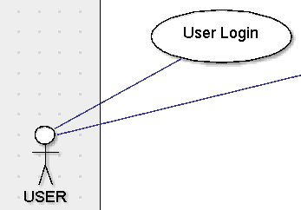

## View Hostel Rooms

**4.2.1 Description and Priority**

This function is available to both the User, and to the Administrator. This helps them to view the Hostel Rooms. So, it stands at a priority labelled ‘A’ which means its having a high priority.

**4.2.2 Stimulus/Response Sequence**

This function can be performed by both the User and the Administrator. In Home page, there will be an option called Housing as a card/button. If User/Administrator choose that after selecting the city, they will directed to Housing page in which there will be three options (i). Rent Houses (ii). Hotel Rooms (iii). Hotel Rooms. In that, if they choose Hostel Rooms, they will directed to a page, which contains information about various Hostels present in different locations in that city.

**4.2.3 Functional Requirements**

REQ-1: There should be an Internet Connection in the User’s device.

REQ-2: There should be a browser in the User’s device through which user can access our website.

REQ-3: There can’t be any faulty inputs to this function as it is simply viewing the Hostel Rooms.

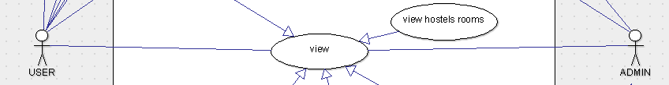

## View Hotel Rooms

**4.3.1 Description and Priority**

This function is available to both the User, and to the Administrator. This helps them to view the Hotel Rooms. So, it stands at a priority labelled ‘A’ which means its having a high priority.

**4.3.2 Stimulus/Response Sequence**

This function can be performed by both the User and the Administrator. In Home page, there will be an option called Housing as a card/button. If User/Administrator choose that after selecting the city, they will directed to Housing page in which there will be three options (i). Rent Houses (ii). Hotel Rooms (iii). Hotel Rooms. In that, if they choose Hotel Rooms, they will directed to a page, which contains information about various Hotels present in different locations in that city.

**4.3.3 Functional Requirements**

REQ-1: There should be an Internet Connection in the User’s device.

REQ-2: There should be a browser in the User’s device through which user can access our website.

REQ-3: There can’t be any faulty inputs to this function as it is simply viewing the Hotel Rooms.

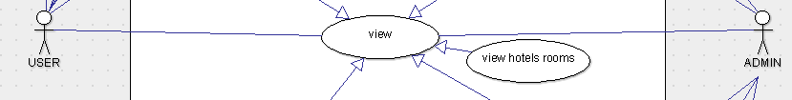

## View Rent Houses

**4.4.1 Description and Priority**

This function is available to both the User, and to the Administrator. This helps them to view the Rent Houses. So, it stands at a priority labelled ‘A’ which means its having a high priority.

**4.4.2 Stimulus/Response Sequence**

This function can be performed by both the User and the Administrator. In Home page, there will be an option called Housing as a card/button. If User/Administrator choose that after selecting the city, they will directed to Housing page in which there will be three options (i). Rent Houses (ii). Hotel Rooms (iii). Hotel Rooms. In that, if they choose Rent Houses, they will directed to a page, which contains information about various Rent Houses present in different locations in that city.

**4.4.3 Functional Requirements**

REQ-1: There should be an Internet Connection in the User’s device.

REQ-2: There should be a browser in the User’s device through which user can access our website.

REQ-3: There can’t be any faulty inputs to this function as it is simply viewing the Rent Houses.

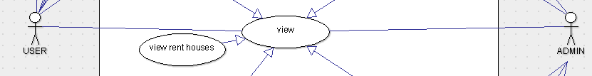

## View Services

**4.5.1 Description and Priority**

This function is available to both the User, and to the Administrator. This helps them to view the Services in that city. So, it stands at a priority labelled ‘A’ which means its having a high priority.

**4.5.2 Stimulus/Response Sequence**

This function can be performed by both the User and the Administrator. In Home page, there will be an option called Services as a card/button. If User/Administrator choose that after selecting the city, they will directed to Services page.

**4.5.3 Functional Requirements**

REQ-1: There should be an Internet Connection in the User’s device.

REQ-2: There should be a browser in the User’s device through which user can access our website.

REQ-3: There can’t be any faulty inputs to this function as it is simply viewing the Services.

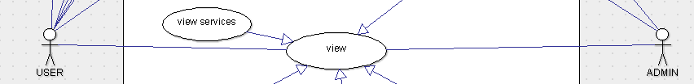

## View Places

**4.6.1 Description and Priority**

This function is available to both the User, and to the Administrator. This helps them to view the Places in that city. So, it stands at a priority labelled ‘A’ which means its having a high priority.

**4.6.2 Stimulus/Response Sequence**

This function can be performed by both the User and the Administrator. In Home page, there will be an option called Places as a card/button. If User/Administrator choose that after selecting the city, they will directed to Places page, which consists of information about different places in that city.

**4.6.3 Functional Requirements**

REQ-1: There should be an Internet Connection in the User’s device.

REQ-2: There should be a browser in the User’s device through which user can access our website.

REQ-3: There can’t be any faulty inputs to this function as it is simply viewing the Places in that city.

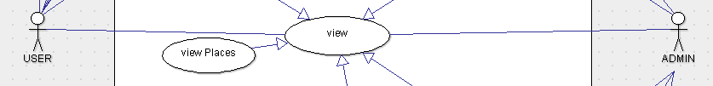

## Search

**4.7.1 Description and Priority**

This function is available to both the User, and to the Administrator. This helps them to add location and do searching based on that location. So, it stands at a priority labelled ‘A’ which means its having a high priority.

**4.7.2 Stimulus/Response Sequence**

This function can be performed by both the User and the Administrator. In Home page, there will be a Location search in which User/Administrator should add city name and do searching based on that search. In Places and Services pages after selecting type of Place/Services, there will be a Location search in which User/Administrator can add a particular place in that city and do searching of Places/Services based on that particular place.

**4.7.3 Functional Requirements**

REQ-1: There should be an Internet Connection in the User’s device.

REQ-2: There should be a browser in the User’s device through which user can access our website.

REQ-3: User/Administrator should give correct location as the input to this function otherwise it will show nothing.

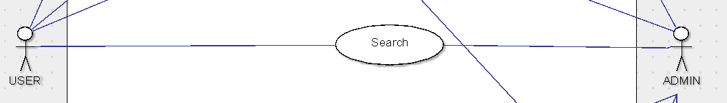

**4.8 Delete hostel rooms**

**4.8.1 Description and priority –**

This helps to delete data of any hostel rooms by the administrator . So, it stands at a priority labelled ‘A’ which means its having a high priority.user cannot do this.

**4.8.2 Stimulus/Response Sequences -**

This function is for Administrator not for User. The process of this function is, first Administrator should signIn in web site, if it is successful there will be an option called Housing as a card/button. If Administrator choose that after selecting the city, Administrator will be directed to Housing page in which there will be option Hostel Rooms. They will directed to a page, which contains list of various Hostel rooms present in different locations in that city. Then Administraror can hover on any item to delete it.

**4.8.3 Functional Requirements**

REQ-1: There should be an Internet Connection in the  User’s device.

REQ-2: There should be a browser in the User’s device through which user can access our website.

REQ-3: There can’t be any faulty inputs to this function as it is simple process.

REQ-4: There should be a valid Administrator to do this function.

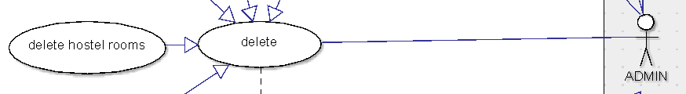

**4.9 Delete hotel rooms**

**4.9.1 Description and priority –**

This helps to delete data of any hotel rooms by the administrator . So, it stands at a priority labelled ‘A’ which means its having a high priority. User cannot do this.

**4.9.2 Stimulus/Response Sequences -**

This function is for Administrator not for User.the process of this function is first Administrator should signIn in web site, if it is successful there will be an option called Housing as a card/button. If Administrator choose that after selecting the city, Administrator will directed to Housing page in which there will be option Hotel rooms. They will directed to a page, which contains list of various Hostel rooms present in different locations in that city. Then administraror can hover on any item to delete it.

**4.9.3 Functional Requirements**

REQ-1: There should be an Internet Connection in the  User’s device.

REQ-2: There should be a browser in the User’s device through which user can access our website.

REQ-3: There can’t be any faulty inputs to this function as it is simple process.

REQ-4: There should be a valid Administrator to do this function.

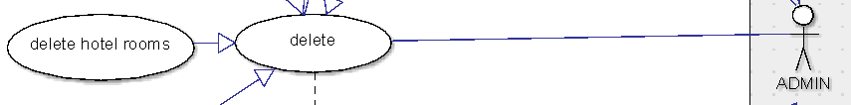

**4.10 Delete rent house**

**4.10.1 Description and priority –**

This helps to delete data of any rent house by the administrator . So, it stands at a priority labelled ‘A’ which means its having a high priority. User cannot do this.

**4.10.2 Stimulus/Response Sequences -**

This function is for Administrator not for User. The process of this function is first Administrator should signIn in web site, if it is successful there will be an option called Housing as a card/button. If Administrator choose that after selecting the city, Administrator will directed to Housing page in which there will be option Rent house. they will directed to a page, which contains list of various rent house present in different locations in that city. Then administraror can hover on any item to delete it.

**4.10.3 Functional Requirements**

REQ-1: There should be an Internet Connection in the  User’s device.

REQ-2: There should be a browser in the User’s device through which user can access our website.

REQ-3: There can’t be any faulty inputs to this function as it is simple process.

REQ-4: There should be a valid Administrator to do this function.

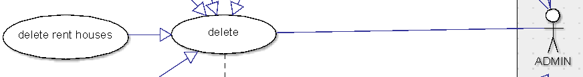

**4.11 Delete places**

**4.11.1 Description and priority –**

This helps to delete data of any places by the Administrator . So, it stands at a priority labelled ‘A’ which means its having a high priority. User cannot do this.

**4.11.2 Stimulus/Response Sequences -**

This function is for Administrator not for User.the process of this function is first Administrator should signIn in web site, if it is successful there will be an option called places as a card/button. If Administrator choose that after selecting the city, Administrator will directed to places page in which there will be different catagerious of places. On selecting any of option they will directed to a page, which contains list of various places present in different locations in that city. Then administraror can hover on any item to delete it.

**4.11.3 Functional Requirements**

REQ-1: There should be an Internet Connection in the  User’s device.

REQ-2: There should be a browser in the User’s device through which user can access our website.

REQ-3: There can’t be any faulty inputs to this function as it is simple process.

REQ-4: There should be a valid Administrator to do this function.

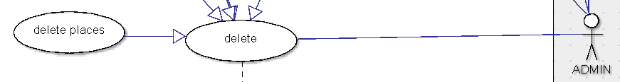

**4.12 Delete services**

**4.12.1 Description and priority –**

This helps to delete data of any services by the administrator . So, it stands at a priority labelled ‘A’ which means its having a high priority.user cannot do this.

**4.12.2 Stimulus/Response Sequences -**

This function is for Administrator not for user.the process of this function is first Administrator should signIn in web site,if it is successful there will be an option called services as a card/button. If Administrator choose that after selecting the city, Administrator will directed to services page in which there will be different catagerious of services. On selecting any of option they will directed to a page, which contains list of various service providers present in different locations in that city. then administraror can hover on any item to delete it.

**4.12.3 Functional Requirements**

REQ-1: There should be an Internet Connection in the  User’s device.

REQ-2: There should be a browser in the User’s device through which user can access our website.

REQ-3: There can’t be any faulty inputs to this function as it is simple process.

REQ-4: There should be a valid Administrator to do this function.

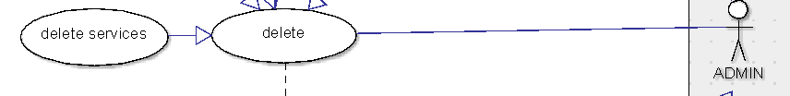

**4.13 Update hostel rooms**

**4.13.1 Description and priority –**

This helps to modify data of any hostel rooms by the administrator . So, it stands at a priority labelled ‘A’ which means its having a high priority.user cannot do this.

**4.13.2 Stimulus/Response Sequences -**

This function is for Administrator not for user.the process of this function is first Administrator should signIn in web site,if it is successful there will be an option called Housing as a card/button. If Administrator choose that after selecting the city, Administrator will directed to Housing page in which there will be option Hostel Rooms. they will directed to a page, which contains list of various Hostel rooms present in different locations in that city. then administraror can hover on any item to modify it.

**4.13.3 Functional Requirements**

REQ-1: There should be an Internet Connection in the  User’s device.

REQ-2: There should be a browser in the User’s device through which user can access our website.

REQ-3: There can’t be any faulty inputs to this function as it is simple

REQ-4: There should be a valid Administrator to do this function.

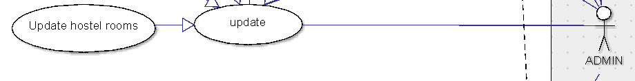

**4.14 Update hotel rooms**

**4.14.1 Description and priority –**

This helps to modify data of any hotel rooms by the administrator . So, it stands at a priority labelled ‘A’ which means its having a high priority.user cannot do this.

**4.14.2 Stimulus/Response Sequences -**

This function is for Administrator not for user.the process of this function is first Administrator should signIn in web site,if it is successful there will be an option called Housing as a card/button. If Administrator choose that after selecting the city, Administrator will directed to Housing page in which there will be option Hotel Rooms. they will directed to a page, which contains list of various Hotel rooms present in different locations in that city. then administraror can hover on any item to modify it.

**4.14.3 Functional Requirements**

REQ-1: There should be an Internet Connection in the  User’s device.

REQ-2: There should be a browser in the User’s device through which user can access our website.

REQ-3: There can’t be any faulty inputs to this function as it is simple process.

REQ-4: There should be a valid Administrator to do this function.

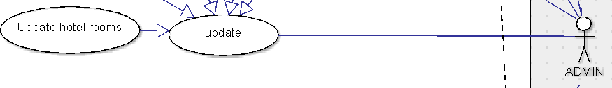

**4.15 Update Rent Houses**

**4.15.1 Description and priority –**

This function is not available to the user. This helps in data updation by the administrator . So, it stands at a priority labelled ‘A’ which means its having a high priority.

**4.15.2 Stimulus/Response Sequences –**

This specific function can be neither performed by user as an action nor can be viewed by the user. This function is an action carried out by the administrator which provides the ability to modify the data by addition or deletion. This will benefit the user when he wants to view the rented houses in a specific area. It is not a function which gives a direct reaction for a user’s action but the action is performed by the admin and is useful to the customer. This action is available to perform when the adminbistrator logs in.

**4.15.3 Functional Requirements –**

REQ 1 : The list which is to be updated must be available beforehand

REQ 2: There should be an internet connection.

REQ 3: A browser must be present.

REQ 4:There cant be any faulty inputs to this function as it can’t be viewed by the user.

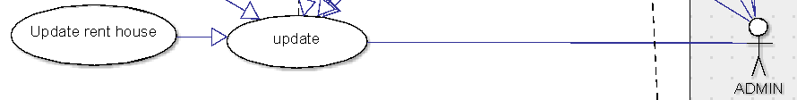

**4.16 Update Places –**

**4.16.1 Description and priority –**

This function is not available to the user. This helps in data updation by the administrator . So, it stands at a priority labelled ‘A’ which means its having a high priority.

**4.16.2 Stimulus/Response Sequences –**

This specific function can be neither performed by user as an action nor can be viewed by the user. This function is an action carried out by the administrator which provides the ability to modify the data by addition or deletion of the list of places such as parks , multiplexes and other useful data of an area. This will benefit the user when he wants to view the places in a specific area when he is new to a city. It is not a function which gives a direct reaction for a user’s action but the action is performed by the admin and is beneficial for the customer. This action is available to perform when the adminbistrator logs in.

**4.16.3 Functional Requirements –**

REQ 1 : The list which is to be updated must be available beforehand

REQ 2: There should be an internet connection.

REQ 3: A browser must be present.

REQ 4:There cant be any faulty inputs to this function as it can’t be viewed by the user.

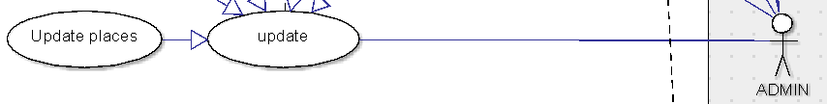

**4.17 Update Services –**

**4.17.1 Description and priority –**

This function is not available to the user. This helps in data updation by the administrator . So, it stands at a priority labelled ‘A’ which means its having a high priority.

**4.17.2 Stimulus/Response Sequences –**

This specific function can be neither performed by user as an action nor can be viewed by the user. This function is an action carried out by the administrator which provides the ability to modify the data by addition or deletion of the list of services such as hospitals, painting staff , furniture shops , packers and other useful services of an area. This will benefit the user when he wants to be benefited by a certain sevice in a specific area when he is new to a city. It is not a function which gives a direct reaction for a user’s action but the action is performed by the admin and is beneficial for the customer. This action is available to perform when the adminbistrator logs in.

**4.17.3 Functional Requirements –**

REQ 1 : The list which is to be updated must be available beforehand

REQ 2: There should be an internet connection.

REQ 3: A browser must be present.

REQ 4:There cant be any faulty inputs to this function as it can’t be viewed by the user.

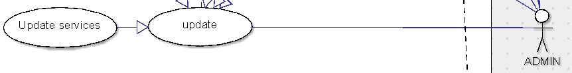

**4.18 Add Hostel Rooms –**

**4.18.1 Description and priority –**

This function is not available to the user. This helps in data addition by the administrator . So, it stands at a priority labelled ‘A’ which means its having a high priority.

**4.18.2 Stimulus/Response Sequences –**

This specific function can be neither performed by user as an action nor can be viewed by the user. This function is an action carried out by the administrator which results in the ability for the admin to add a specific hostel to the list of hostels. This will benefit the user when he wants to get into a new hostel in an area. It is not a function which gives a direct reaction for a user’s action but the action is performed by the admin and is beneficial for the customer. This action is available to be performed once the admin chooses to update hostel rooms after logging in.

**4.18.3 Functional Requirements –**

REQ 1 : The list which is to be added must be available beforehand

REQ 2: There should be an internet connection.

REQ 3: A browser must be present.

REQ 4:There cant be any faulty inputs to this function as it can’t be viewed by the user.

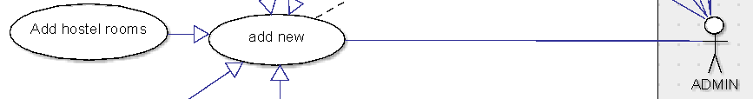

**4.19 Add Hotel Rooms –**

**4.19.1 Description and priority –**

This function is not available to the user. This helps in data addition by the administrator . So, it stands at a priority labelled ‘A’ which means its having a high priority.

**4.19.2 Stimulus/Response Sequences –**

This specific function can be neither performed by user as an action nor can be viewed by the user. This function is an action carried out by the administrator which results in the ability for the admin to add a specific hotel to the list of hotels. This will benefit the user when he wants to get into a new hotel in an area. It is not a function which gives a direct reaction for a user’s action but the action is performed by the admin and is beneficial for the customer. This action is available to be performed once the admin chooses to update hotel rooms after logging in.

**4.19.3 Functional Requirements –**

REQ 1 : The list which is to be added must be available beforehand

REQ 2: There should be an internet connection.

REQ 3: A browser must be present.

REQ 4:There cant be any faulty inputs to this function as it can’t be viewed by the user.

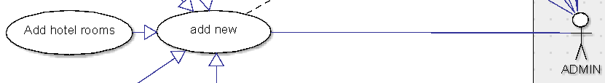

**4.20 Add Rent Houses –**

**4.20.1 Description and priority –**

This function is not available to the user. This helps in data addition by the administrator . So, it stands at a priority labelled ‘A’ which means its having a high priority.

**4.20.2 Stimulus/Response Sequences –**

This specific function can be neither performed by user as an action nor can be viewed by the user. This function is an action carried out by the administrator which results in the ability for the admin to add a specific rent house to the list of rent houses. This will benefit the user when he wants to get into a new rent house in an area. It is not a function which gives a direct reaction for a user’s action but the action is performed by the admin and is beneficial for the customer. This action is available to be performed once the admin chooses to update rent houses after logging in.

**4.20.3 Functional Requirements –**

REQ 1 : The list which is to be added must be available beforehand

REQ 2: There should be an internet connection.

REQ 3: A browser must be present.

REQ 4:There cant be any faulty inputs to this function as it can’t be viewed by the user.

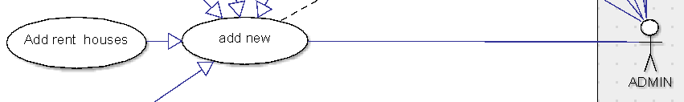

**4.21 Add Places –**

**4.21.1 Description and priority –**

This function is not available to the user. This helps in data addition by the administrator . So, it stands at a priority labelled ‘A’ which means its having a high priority.

**4.21.2 Stimulus/Response Sequences –**

This specific function can be neither performed by user as an action nor can be viewed by the user. This function is an action carried out by the administrator which results in the ability for the admin to add a specific place to the list of places. This will benefit the user when he wants to know about new places in an area. It is not a function which gives a direct reaction for a user’s action but the action is performed by the admin and is beneficial for the customer. This action is available to be performed once the admin chooses to update places after logging in.

**4.21.3 Functional Requirements –**

REQ 1 : The list which is to be added must be available beforehand

REQ 2: There should be an internet connection.

REQ 3: A browser must be present.

REQ 4:There cant be any faulty inputs to this function as it can’t be viewed by the user.

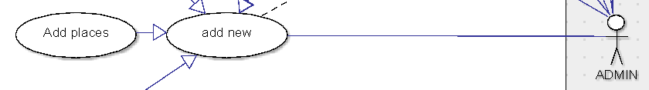

**4.22 Add services –**

**4.22.1 Description and priority –**

This function is not available to the user. This helps in data addition by the administrator . So, it stands at a priority labelled ‘A’ which means its having a high priority.

**4.22.2 Stimulus/Response Sequences –**

This specific function can be neither performed by user as an action nor can be viewed by the user. This function is an action carried out by the administrator which results in the ability for the admin to add a specific service to the list of services. This will benefit the user when he wants to know the services provided in an area. It is not a function which gives a direct reaction for a user’s action but the action is performed by the admin and is beneficial for the customer. This action is available to be performed once the admin chooses to update services after logging in.

**4.22.3 Functional Requirements –**

REQ 1 : The list which is to be added must be available beforehand

REQ 2: There should be an internet connection.

REQ 3: A browser must be present.

REQ 4:There cant be any faulty inputs to this function as it can’t be viewed by the user.

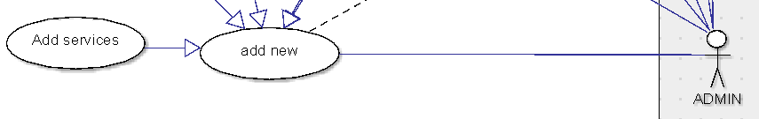

**4.23 Booking**

**4.23.1 Description and priority**

This function is available to the user. This allows the user to book his preferred room or service. So, it stands at a priority labeled ‘A’ which means its having a high priority.

**4.23.2 Stimulus/Response Sequences –**

This specific function can be either performed by user as an action or can be viewed by the user. This function is an action carried out by the user which results in the ability for the user to book a specific room in a hotel or a hostel . This will benefit the user when he wants to get a room in a new city without appearing physically. This action is available to the user once he logs in , selects his location and chooses housing , he can either book a hotel room or a hostel room. Once you book a room , your payment mechanism starts and once the payment is completed successfully ,the user will get an SMS which confirms his/her booking.

**4.23.3 Functional Requirements –**

REQ 1 : The user must have an internet connection.

REQ 2 : He must have a supporting browser.

REQ 2 : He must already be logged in .

REQ 3 : The location must be chosen already.

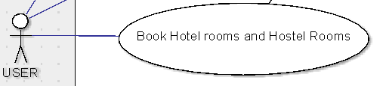

**4.24 Admin Login**

**4.24.1 Description and priority**

This function is not available to the user. This allows the administrator to log in to his dashboard where he can perform certain tasks. So, it stands at a priority labelled ‘A’ which means its having a high priority.

**4.24.2 Stimulus/Response Sequences –**

This specific function can be neither performed by user as an action nor can be viewed by the user. This is a function on which the admin has to act if he wants to modify any kind of data. This provides the ability to the admin to perform any kind of task. The admin need to put certain information like username and password to get authenticated and further helping him to perform his tasks.

**4.24.3 Functional Requirements –**

REQ 1 : The admin must already be registered.

REQ 2 : The user must have an internet connection.

REQ 3 : He must have a supporting browser.

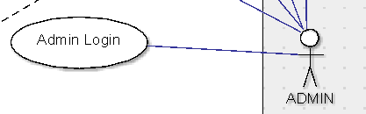

**4.25 Rating**

**4.25.1 Description and priority –**

This function is available only to the user. This allows the user to rate his experience after using the service. So, it stands at a priority labelled ‘B’ which means its having a high priority.

**4.25.2 Stimulus/Response Sequences –**

This specific function can be either performed by user as an action or can be viewed by the user. This function is an action carried out by the user which provides the ability to rate his experience over a particular service in an area. This will benefit the other users to look upon a particular service to choose whether to take that specified service or not. This action is available to perform when the user logs in. A scale of 1 to 10 is provided to the user after the service is used where the user puts his rating.

**4.25.3 Functional Requirements –**

REQ 1 : The user must have already been logged in.

REQ 2 : The user must have an internet connection.

REQ 3 : He must have a supporting browser.

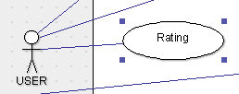

**4.26 Review/Feedback -**

**4.26.1 Description and priority –**

This function is available only to the user. This allows the user to give feedback or review based on his experience after using the service or the website. So, it stands at a priority labelled ‘B’ ,which means its having a high priority.

**4.26.2 Stimulus/Response Sequences –**

This specific function can be either performed by user as an action or can be viewed by the user. This function is an action carried out by the user which provides the ability to give feedback based on his experience over a particular service in an area or . The user puts his opinions which also help in the improvement of the service or the website. This will benefit the other users to look upon a particular service to choose whether to take that specified service or not. This action is available to perform when the user logs in. This is a written feedback in which the user can describe his experience.

**4.26.3 Functional Requirements –**

REQ 1 : The user must have already been logged in.

REQ 2 : The user must have an internet connection.

REQ 3 : He must have a supporting browser.

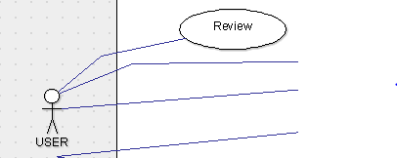

**4.27 Wallet**

**4.27.1 Description and priority –**

This function is available to the user. This action allows the user for payments after bookings. The user can carry on with the payments once he adds money to his wallet which is provided after the user is registered. So, it stands at a priority labelled ‘B’ which means its having a high priority.

**4.27.2 Stimulus/Response Sequences –**

This specific function can be used by both user and admin. Both has different functions for this action. The user can add money and proceed to payments. The admin can update the things regarding it. This action is only available after the user or admin’s login.

**4.27.3 Functional Requirements –**

REQ 1 : The user must have already been logged in.

REQ 2 : The user must have an internet connection.

REQ 3 : He must have a supporting browser.

REQ 4 : Adding money to wallet by the user , In case he wants to book something.

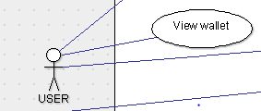

**5 Other Non – Functional Requirements**

**5.1 Performance Requirements –**

When an user gives an input of his location , it takes about 5 seconds for the software to retrieve the data regarding that city and show the options . When searched by location , any specific task takes about 2 seconds . Time delay to book any stay depends on the particular mechanism you choose to book through but none of them take more than 15 seconds in the worst case. The details of a specific place , service , stay will be shown in <2 seconds without any delay.

**5.2 Safety Requirements –**

Information transmission should be securely transmitted to server without any changes in information .The payments must be done in the prescribed way .

**5.3 Security Requirements –**

The main security concern is for users account hence proper login mechanism should be used to avoid hacking. When you sign up through your mobile number , an OTP will be sent to make sure that your account is secure and a verification E-mail will be sent in case of other kinds of sign ups.

**5.4 Software Quality Attributes –**

### 5.4.1 Availability

If the internet service gets disrupted while sending information to the server, the information can be send again for verification.

### 5.4.2 Usability

As the system is easy to handle and navigates in the most expected way with no delays. In that case the system program reacts accordingly and transverses quickly between its states.

**5.4.3 Correctness**

The application responds to you depending on your location in every aspect with the results which are in your viscinity and their current state will be mentioned.

**5.4.4 Portability**

The application is portable and supported on almost all the common platforms we use like the mostly used browsers.

**Business Rules**

Under any circumstance , any modification to be done to the data or to the application , it will be completely in the hands of the administrator . The users who don’t log in are open to some features of the application as they are not considered reliable until they become verified users . The users who login are open to all the facilities and the features of the application . Once the process of booking starts , the server is directed to the particular payment platform and at that moment , the user is suggested not to perform any action.

# Other Requirements

All the requirements are mentioned in their respective sections .

**Appendix A: Glossary**

Admin – Administrator

A -High Priority

B – Low Priority

**Appendix B: Analysis Models**

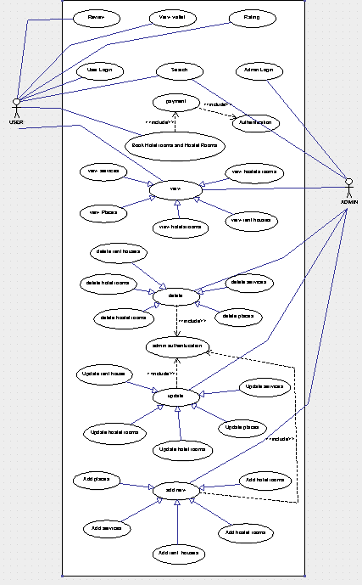

**Appendix C: To Be Determined List**

There are no to be determined components as per the design done till now.